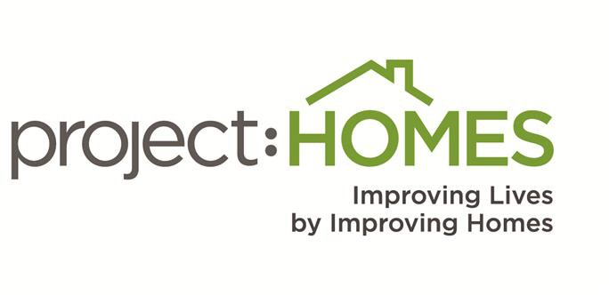

PRIVACY POLICY

project:HOMES is committed to protecting your privacy. Please visit our website to browse and download information, make a donation, or send us an e-mail. The terms and conditions outlined below govern any use of this site. By signing on and using this website, you acknowledge and agree to the following:

Warranties
All information contained in this site is provided “as is” and project:HOMES makes no warranties of any kind that the services provided by this site or any linked site will be uninterrupted, error free, or that the site or the server that hosts this site are free from viruses or other forms of harmful computer code.

Liability
In no event shall project:HOMES, its employees, agents or anyone involved in the creation, maintenance, production or delivery of these pages, be liable for any direct, incidental, or consequential damages resulting from the use of this site or any linked Site.

Downloads
You may download material from this website for your own personal, noncommercial use only, provided that such materials are kept intact including all copyright and other proprietary notices.

Donations to project:HOMES
Although project:HOMES is a non-profit, charitable organization, it cannot offer individual advice concerning the financial and/or taxable status of donations. You should consult your personal financial or tax advisor for such advice.

E-mail Communication
Personal information you transmit to project:HOMES may be used by our staff to provide answers to your questions and information about the services we provide. Since e-mail messages may not be secure against interception by unauthorized individuals, you may wish to call or write to us when it is necessary to provide sensitive or personal information. Likewise, we will not transmit personal or sensitive information that could compromise or violate your privacy when communicating via e-mail.

Personal Information
project:HOMES will make every effort to ensure that the personal information you submit to our website is held confidential at all times. Notwithstanding it is understood that personal information posted by you on this website is at your own risk. We do not provide personal information to third parties for commercial or independent use. Our personnel are authorized to access personal information only based on their need to deal with the information for the reason(s) for which it was obtained including but not limited to processing donations and pledges, monitoring site traffic, and other administrative tasks. Access to personal data is restricted to limited staff members.

Our online donation portal uses Secure Sockets Layer (SSL) technology to encrypt all data submitted to and from their site, keeping donors’ personal information as secure as possible. Donor details are maintained in an online donor database which also utilizes SSL encryption to ensure all personal data is protected.

Links to Other Web Sites
For your convenience, our website may provide links to other sites. However, project:HOMES is not responsible for the privacy practices or the content of the websites to which we link. When you link to another site, you are no longer on the project:HOMES website and this Privacy Statement will not apply. When you link to another website, you are subject to the privacy policy of that new site. If you have questions or concerns, please read the privacy and security information for that site.

General
project:HOMES reserves the right to change, amend, or discontinue any aspect or feature of this policy at any time. Any subsequent use of this website by you constitutes your agreement to such changed terms and conditions. Any rights not expressly granted herein are reserved to project:HOMES.

Whom to Contact
If you have submitted information about yourself through this website and would like us to delete this information from our records, please send an email to lee.householder@projecthomes.org We will make reasonable efforts to delete your personal information from our existing files.

